Vice Admiral Gianfranco ANNUNZIATA
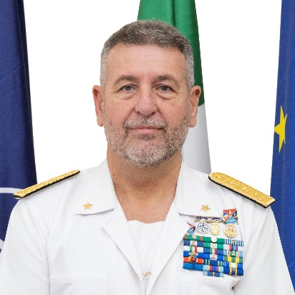
Italian General Defence Staff

Vice Admiral Gianfranco ANNUNZIATA was born in La Maddalena on August 6th, 1967.
He graduated in 1990 with the rank of Ensign and a Master’s degree in Maritime and Naval Sciences.
Surface and Electronic Warfare Officer by trade, his operational assignments include various tour on Destroyers and Frigates.

He commanded Offshore Patrol Vessel LIBRA (Cassiopea Class), Frigate SCIROCCO (Improved Maestrale Class), and Destroyer ANDREA DORIA (Horizon Class), carrying on several operational deployments .

His education includes attendance of the Junior Staff Course at the Naval War College in Livorno, the 110 Senior Course at the NATO Defense College and the 68th Institute for High Defence Studies Course in Rome, holding also a Second Level University Master Degree in Global Strategy and Security at University La Sapienza in Rome.

As Staff Officer he operated in the area of Plans, Policy and Operations at the Italian Navy General Staff in Rome, holding various positions including Deputy Head of Plans, Operations and Maritime Strategy Department and Director of International Engagements.

He then moved to the Cabinet of Minister of Defence, where he held the position of Vice Chief of Cabinet for Military Policy Affairs from October 2018 to March 2022.

Later he held the position of Head 3rd Division – Strategic Direction and Military Cooperation - in the Italian Defence General Staff from march 2022 april 2025.

Since april 2025 VAdm ANNUNZIATA is Senior Strategic Advisor to the Italian Chief of Defence.

Vice Admiral Gianfranco Annunziata is married to Ms Giusi Geromino and is father of three (Matteo, 27, Andrea, 24, and Giulia, 21). Avid football fan, his hobbies include reading, running, basketball and boxing.

